European standard aluminum extrusion profiles:

1. Type : 2020 European standard aluminum profile

Material : aluminum 6063-T5

Weight : 0.55 kg/m

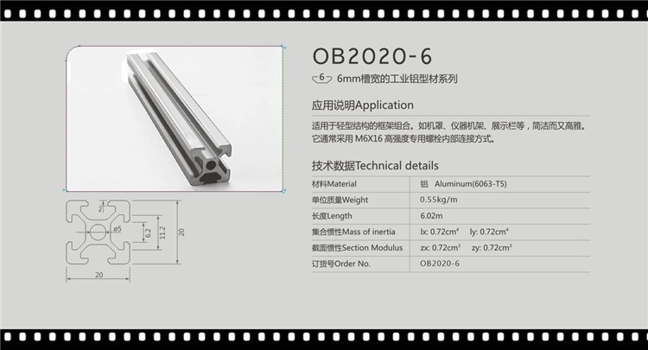

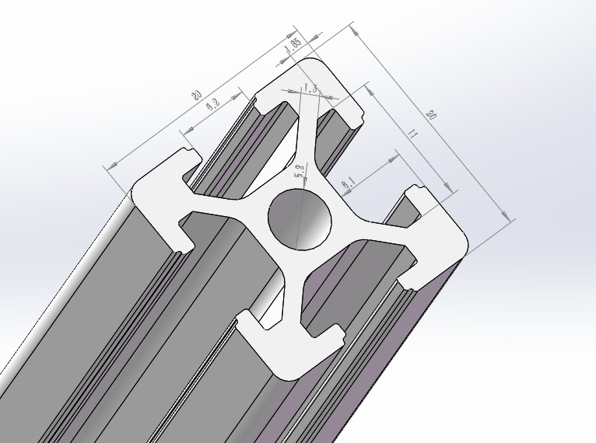

1. Type : 2040 european standard aluminum profile

Material : aluminum 6063-T5

Weight : 1 kg/m

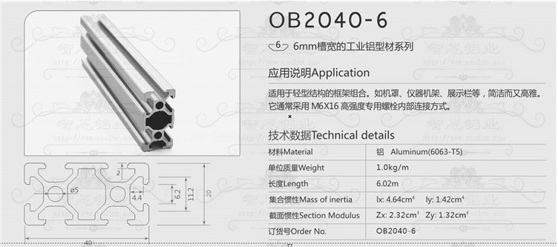

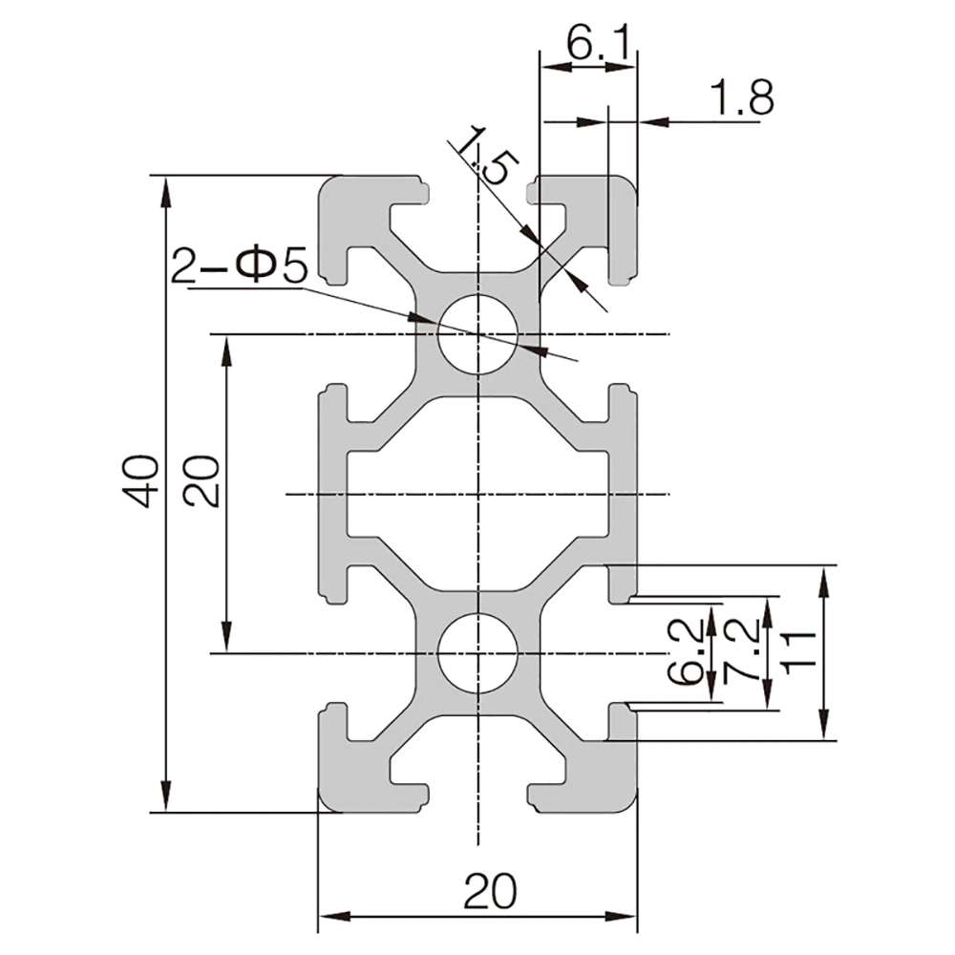

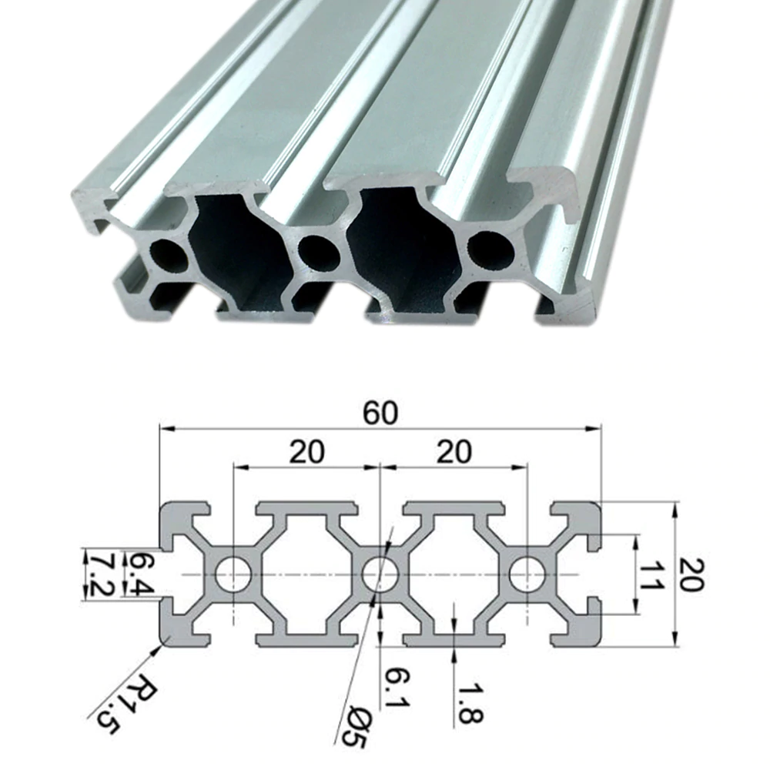

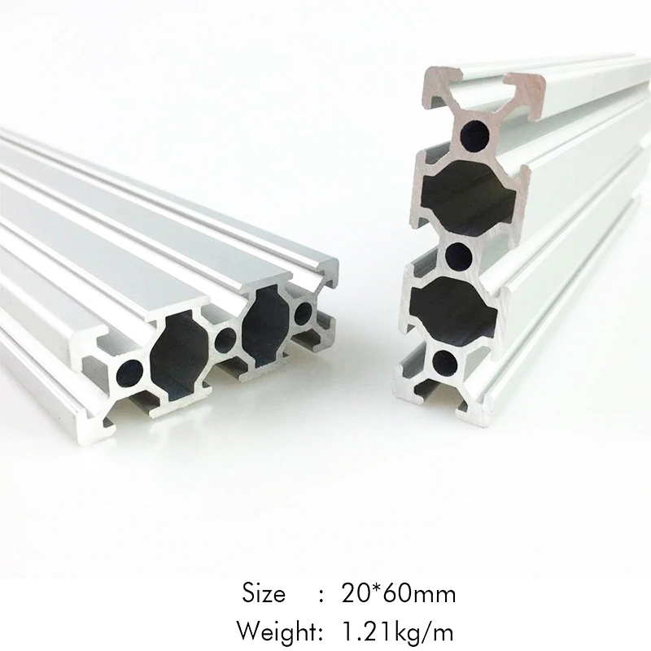

MOTOR ASSEMBLY:

<https://www.aliexpress.com/item/1005001304791067.html?spm=a2g0o.productlist.0.0.46d74101W0qHmo&algo_pvid=87973080-ed2c-4a46-bb1f-014509b45007&algo_expid=87973080-ed2c-4a46-bb1f-014509b45007-3&btsid=0bb0623916134462171338605ee509&ws_ab_test=searchweb0_0,searchweb201602_,searchweb201603>_

MOTOR WITH SUPPORT AND ELASTIC CLUTCH COUPLER 2.16 Kg

2.16 Kg Approximate with a box: h: 69 w: 60 l: 71+133.5+19 =223.5

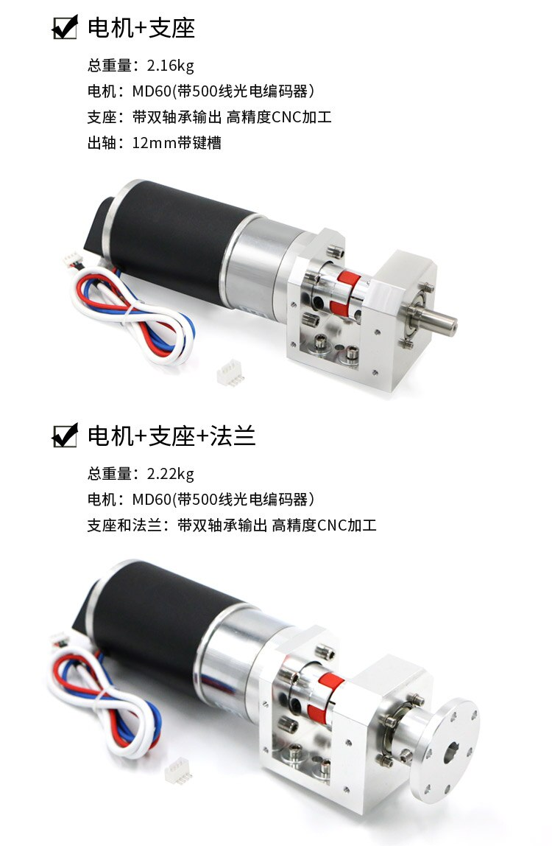

FLANGE 2.22 - 2.16 = 0.06 Kg

approximate with cylinder d: 56.8 l: 26.4+5=31.4

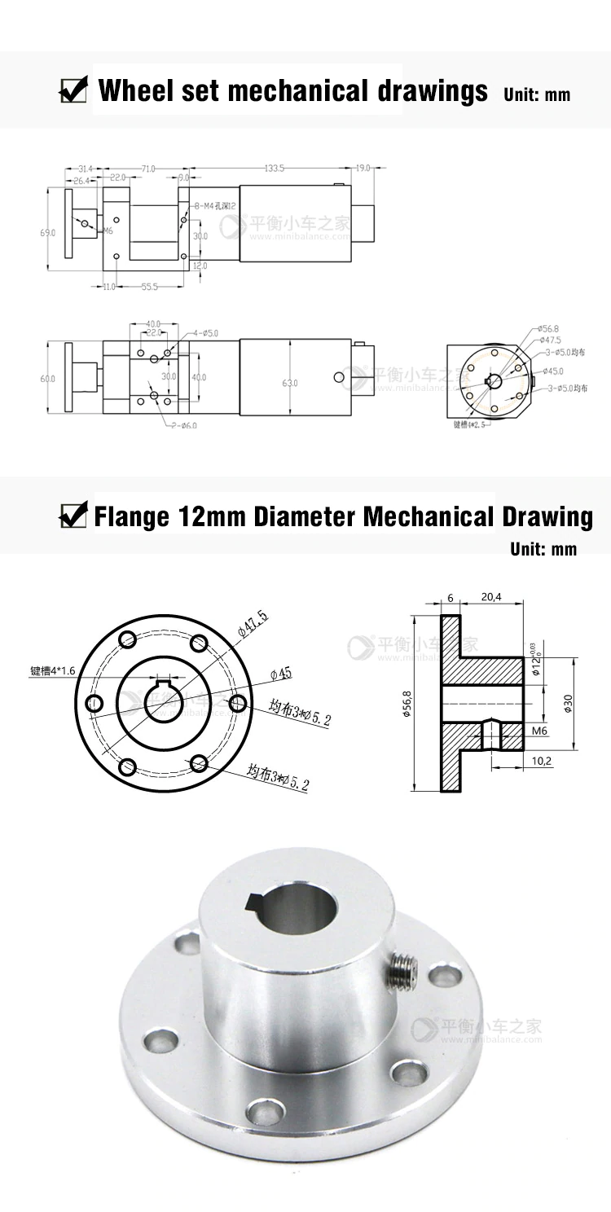MECANUM WHEEL 0.82 Kg.